**OAuth**

Used for delegated **authorization** only -- meaning you are authorizing a third-party service access to use personal data, without giving out a password. Also OAuth "sessions" generally live longer than user sessions. Meaning that OAuth is designed to allow authorization

i.e. Flickr uses OAuth to allow third-party services to post and edit a persons picture on their behalf, without them having to give out their flicker username and password.

**OpenID**

Used to **authenticate** single sign-on identity. All OpenID is supposed to do is allow an OpenID provider to prove that you say you are. However many sites use identity authentication to provide authorization (however the two can be separated out)

i.e. One shows their passport at the airport to authenticate (or prove) the person's who's name is on the ticket they are using is them.

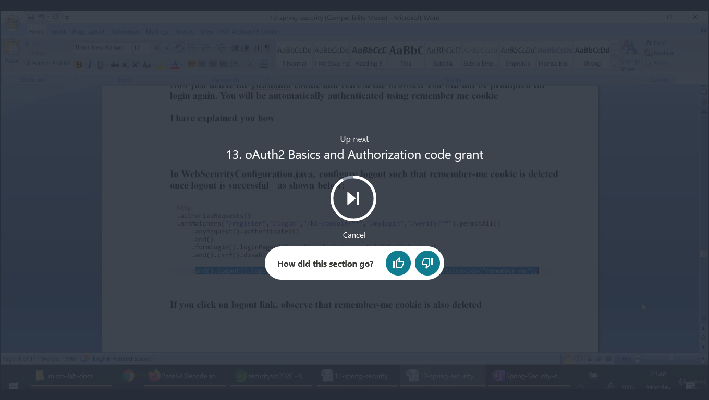

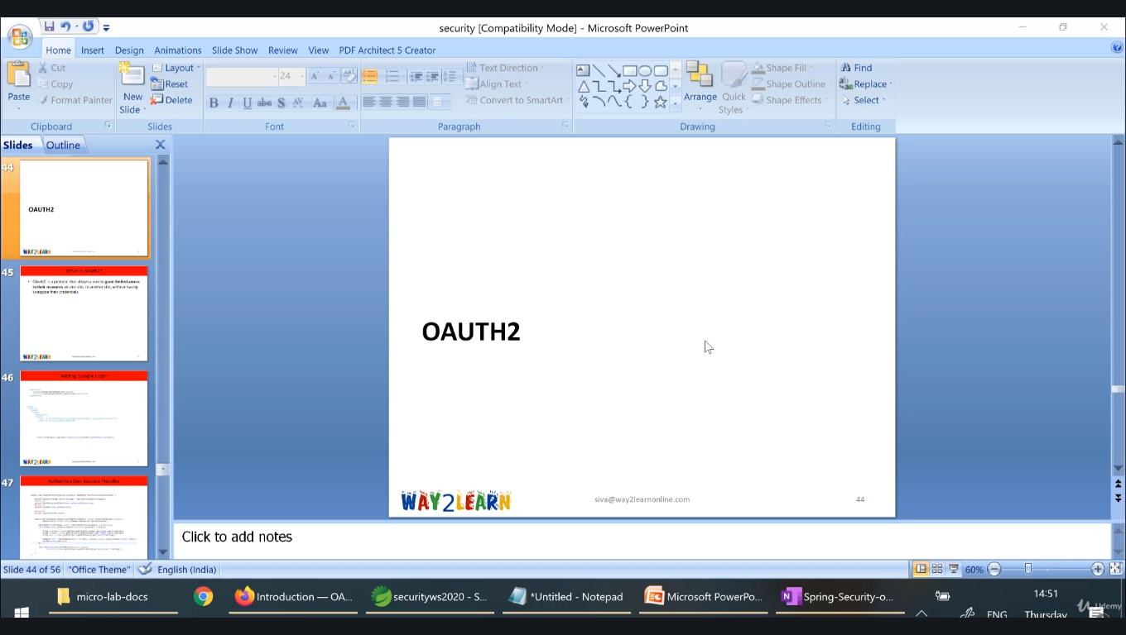

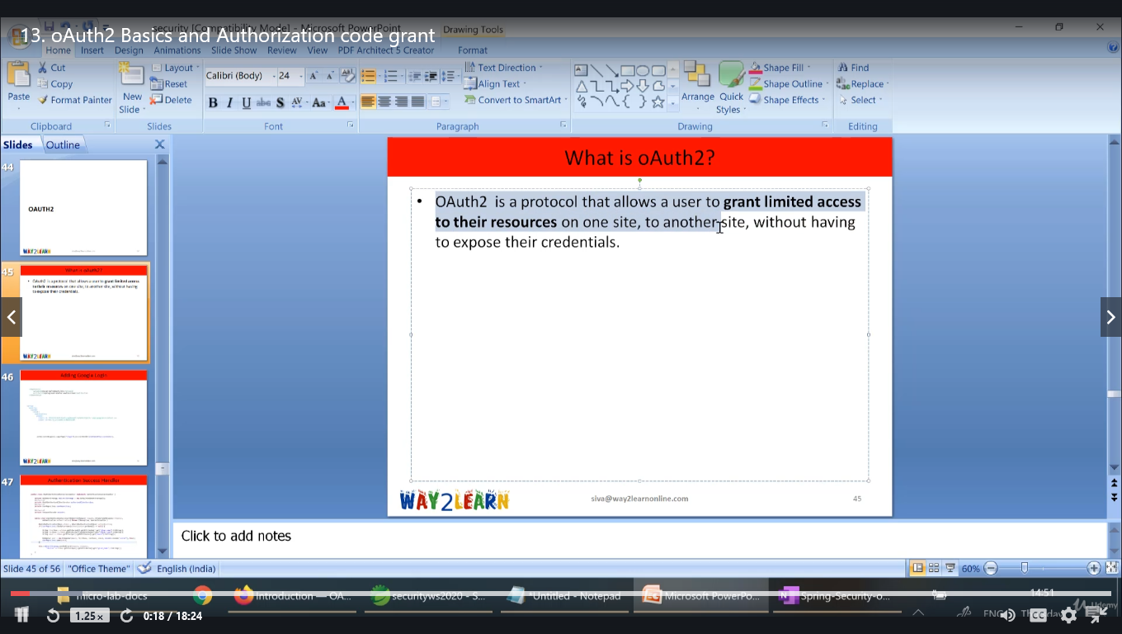

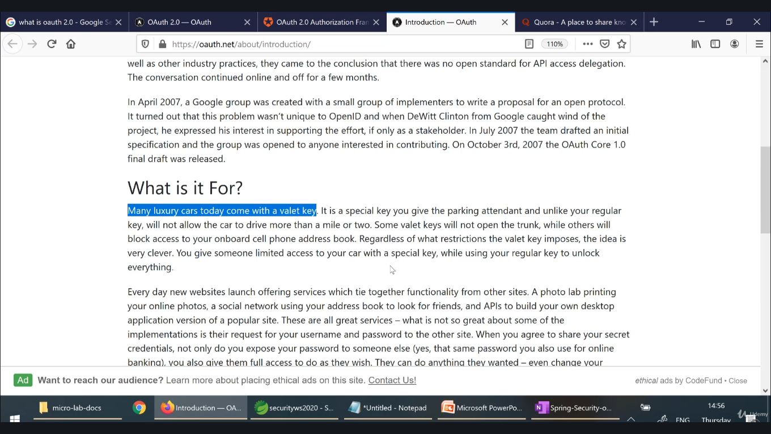

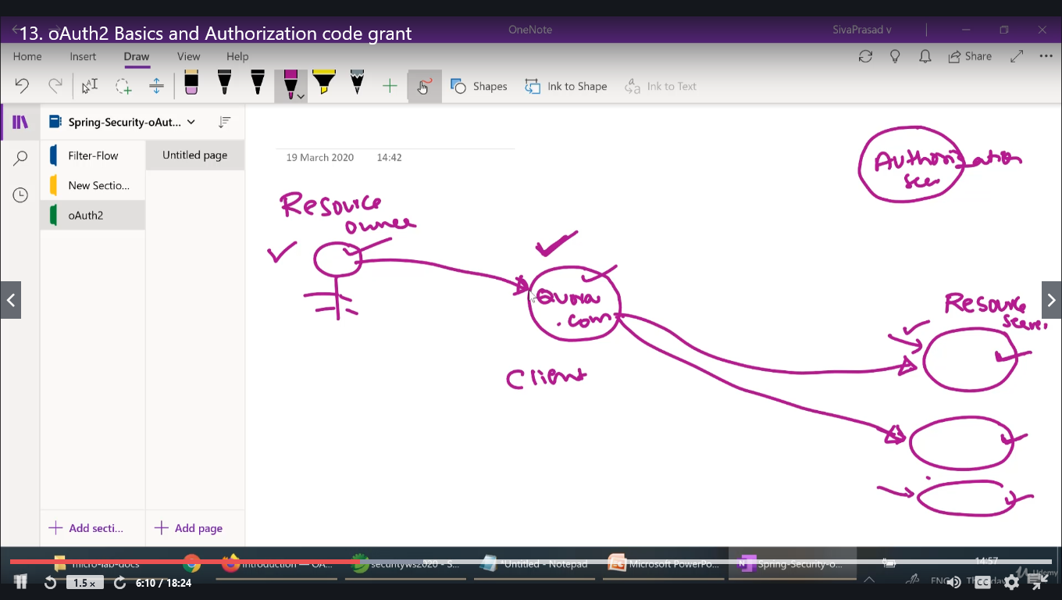

Various types of grants in Oauth2:

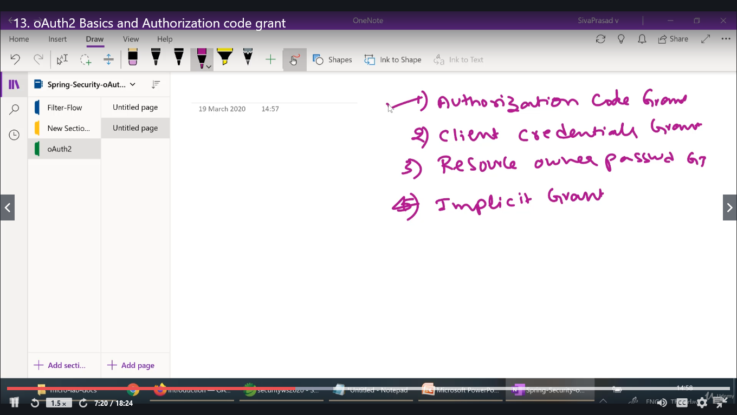

* The OAuth 2.0 Authorization Framework defines four standard grant types: authorization code, implicit, resource owner password credentials, and client credentials. It also provides an extensibility mechanism for defining additional grant types.

**Since:**

5.0

**See Also:**

[Section 1.3 Authorization Grant](https://tools.ietf.org/html/rfc6749#section-1.3), [Serialized Form](https://docs.spring.io/spring-security/site/docs/current/api/serialized-form.html#org.springframework.security.oauth2.core.AuthorizationGrantType)

* + ***Summary***

|  |  |  |
| --- | --- | --- |
| **Fields** | | |
| **Modifier and Type** | **Field** | **Description** |
| static **[AuthorizationGrantType](https://docs.spring.io/spring-security/site/docs/current/api/org/springframework/security/oauth2/core/AuthorizationGrantType.html" \o "class in org.springframework.security.oauth2.core)** | [**AUTHORIZATION_CODE**](https://docs.spring.io/spring-security/site/docs/current/api/org/springframework/security/oauth2/core/AuthorizationGrantType.html#AUTHORIZATION_CODE) |  |
| static **[AuthorizationGrantType](https://docs.spring.io/spring-security/site/docs/current/api/org/springframework/security/oauth2/core/AuthorizationGrantType.html" \o "class in org.springframework.security.oauth2.core)** | [**CLIENT_CREDENTIALS**](https://docs.spring.io/spring-security/site/docs/current/api/org/springframework/security/oauth2/core/AuthorizationGrantType.html#CLIENT_CREDENTIALS) |  |
| static **[AuthorizationGrantType](https://docs.spring.io/spring-security/site/docs/current/api/org/springframework/security/oauth2/core/AuthorizationGrantType.html" \o "class in org.springframework.security.oauth2.core)** | [**IMPLICIT**](https://docs.spring.io/spring-security/site/docs/current/api/org/springframework/security/oauth2/core/AuthorizationGrantType.html#IMPLICIT) | **Deprecated.** |
| static **[AuthorizationGrantType](https://docs.spring.io/spring-security/site/docs/current/api/org/springframework/security/oauth2/core/AuthorizationGrantType.html" \o "class in org.springframework.security.oauth2.core)** | [**JWT_BEARER**](https://docs.spring.io/spring-security/site/docs/current/api/org/springframework/security/oauth2/core/AuthorizationGrantType.html#JWT_BEARER) |  |
| static **[AuthorizationGrantType](https://docs.spring.io/spring-security/site/docs/current/api/org/springframework/security/oauth2/core/AuthorizationGrantType.html" \o "class in org.springframework.security.oauth2.core)** | [**PASSWORD**](https://docs.spring.io/spring-security/site/docs/current/api/org/springframework/security/oauth2/core/AuthorizationGrantType.html#PASSWORD) |  |
| static **[AuthorizationGrantType](https://docs.spring.io/spring-security/site/docs/current/api/org/springframework/security/oauth2/core/AuthorizationGrantType.html" \o "class in org.springframework.security.oauth2.core)** | [**REFRESH_TOKEN**](https://docs.spring.io/spring-security/site/docs/current/api/org/springframework/security/oauth2/core/AuthorizationGrantType.html#REFRESH_TOKEN) |  |

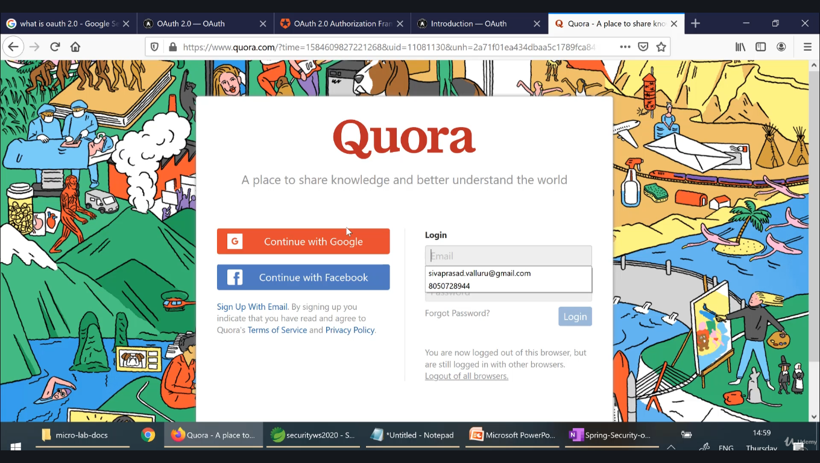

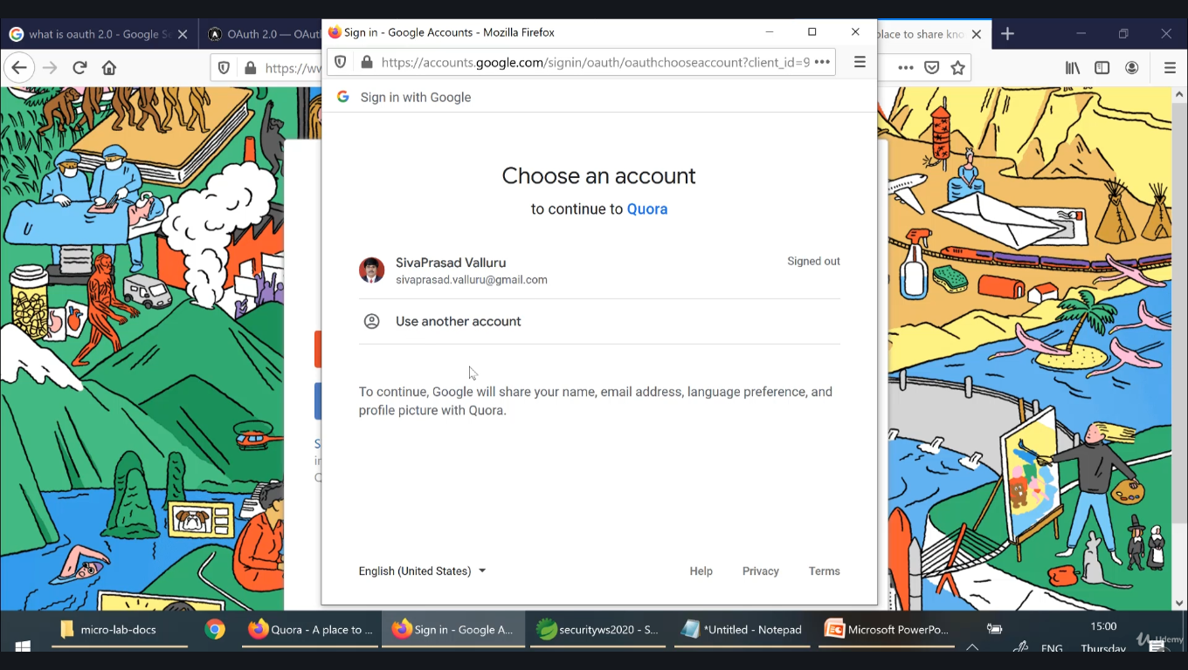

Here Quora is client application

Scope is permission

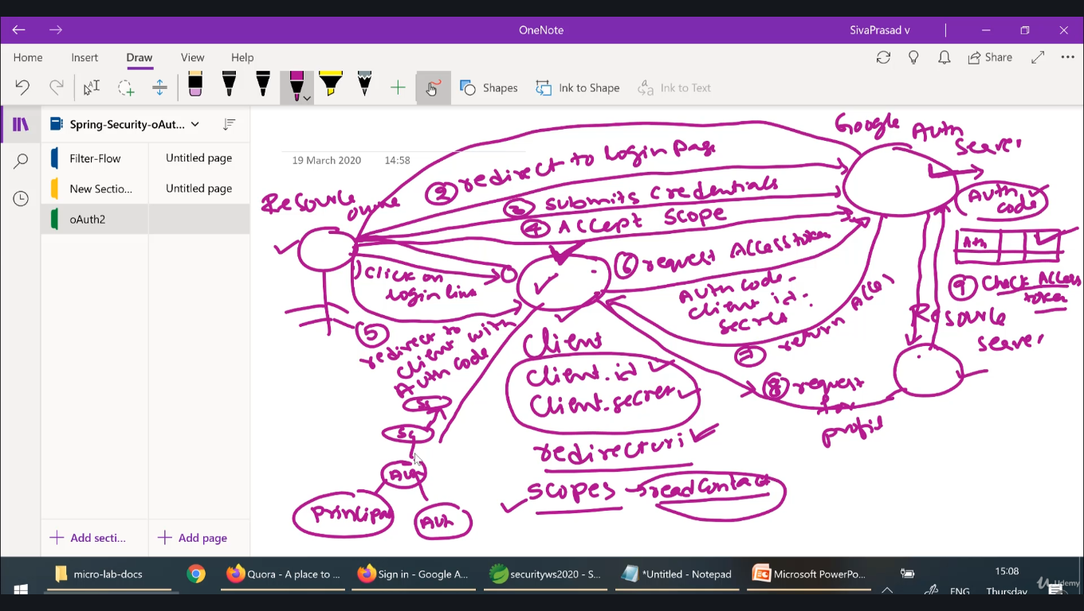

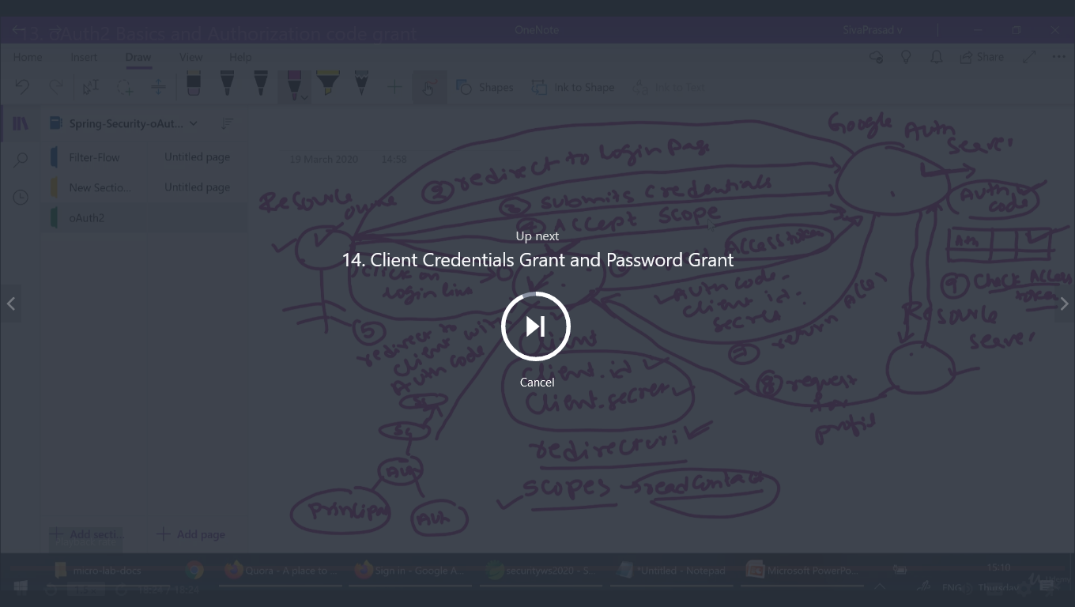

<https://www.oauth.com/oauth2-servers/access-tokens/client-credentials/>

## **Client Credentials Grant Type**

This grant type is for apps that can request an access token and access resources on its own. These apps often use services that call APIs without users.

The following diagram shows the flow for the Client Credentials grant type:

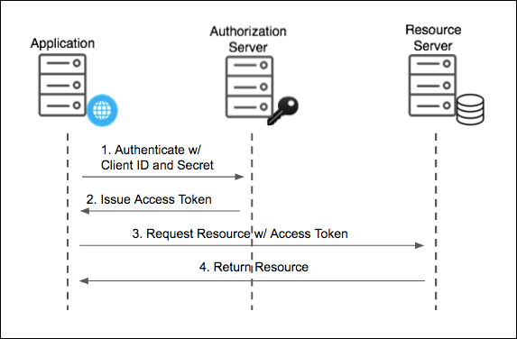

Example bookmyshow, user can book tickets using bookmyshow website and also there other apps who are clients of bookmyshow, from there also user can book tickets

Here bookmyshow interacts with resource owner & Authserver to do booking as it’s has license for the same.

Considering a simple app(lets say shivapp) wants to perform same operation, but it can’t bear the cost of licencing with authserver.. in this case simple app makes an agreement with bookmyshow for the booking , here bookmyshow gives client id & client secret

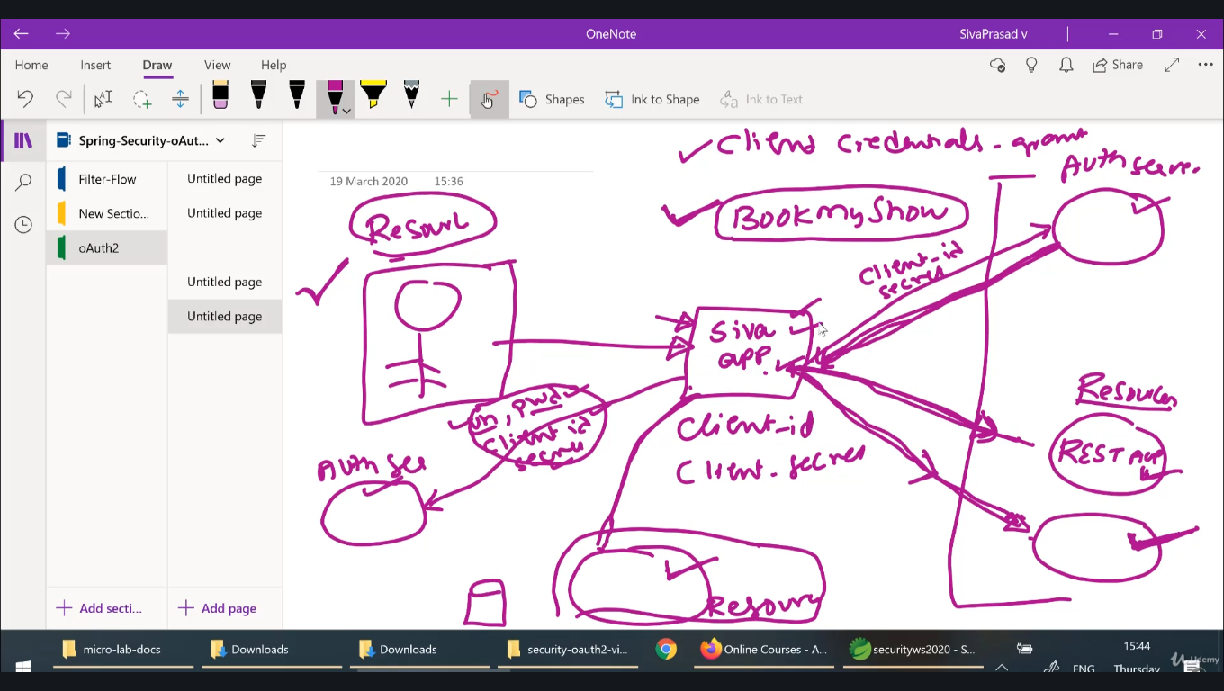

## **Resource Owner Password Grant Type**

For Native Mobile and Desktop apps, Pivotal Single Sign‑On supports the Resource Owner Password OAuth 2.0 grant type. This password grant type is for highly trusted apps where resource owners share their credentials directly with the app.

### Resource Owner Password Flow

The following diagram shows the flow for the Resource Owner Password grant type:

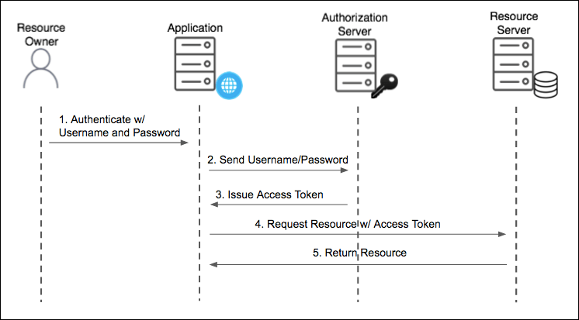

<https://docs.pivotal.io/p-identity/1-11/grant-types.html#auth-code-roles>

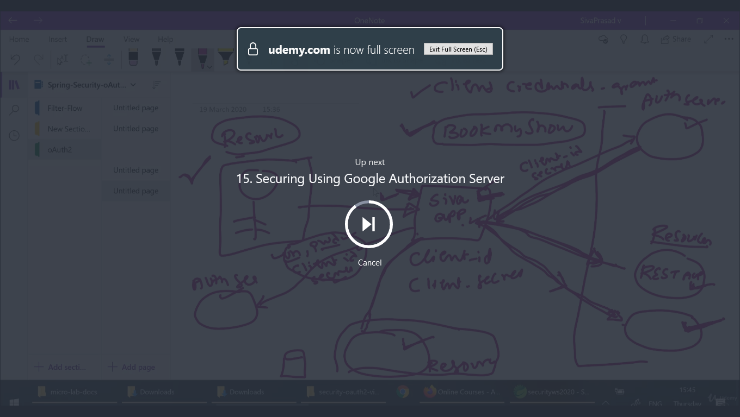

Securing your app with google server

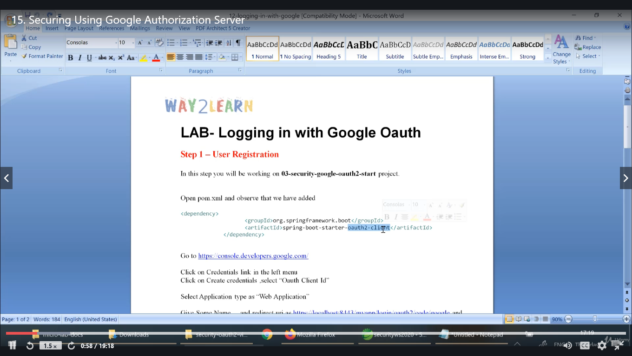

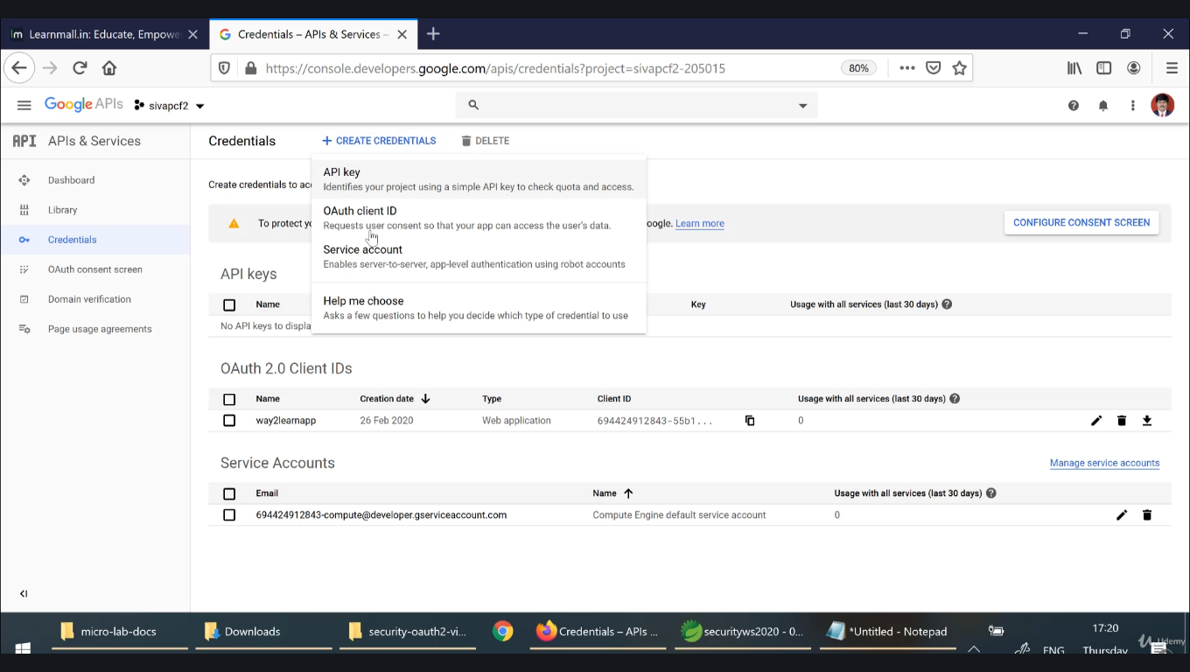

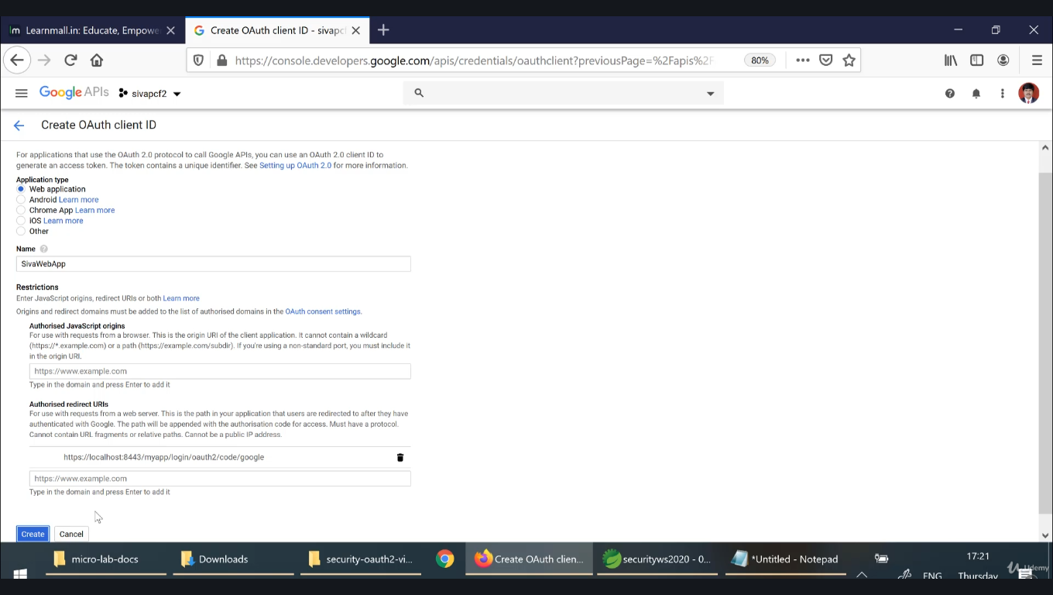

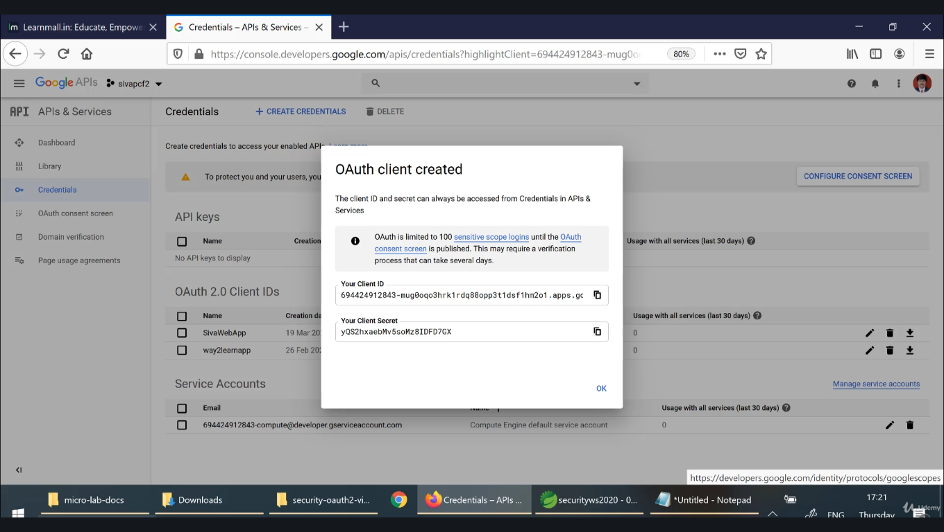

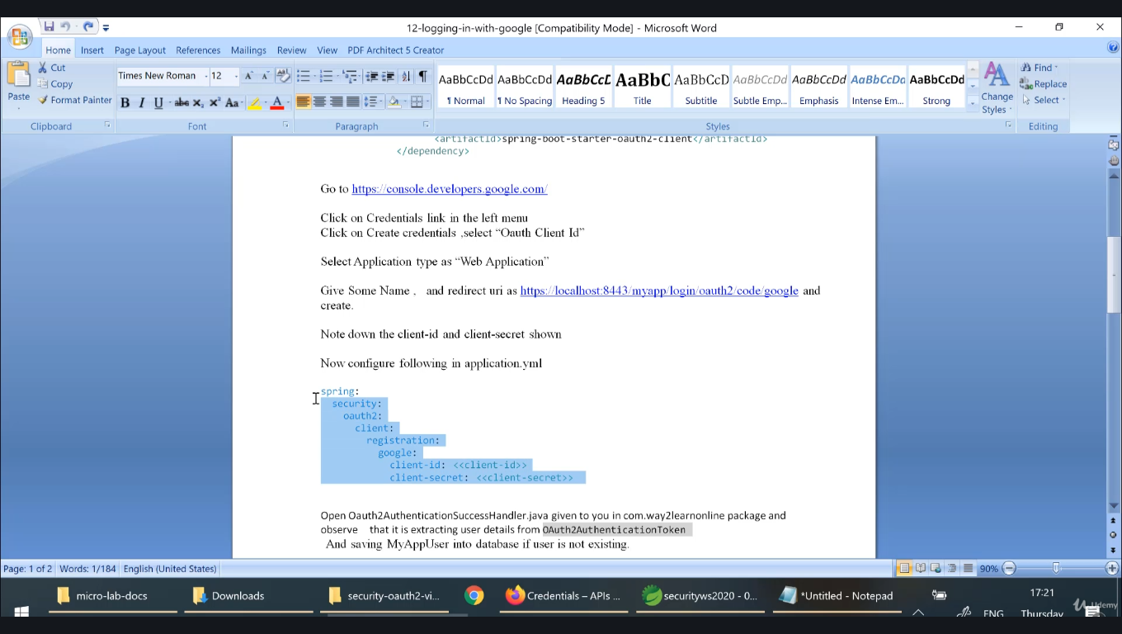

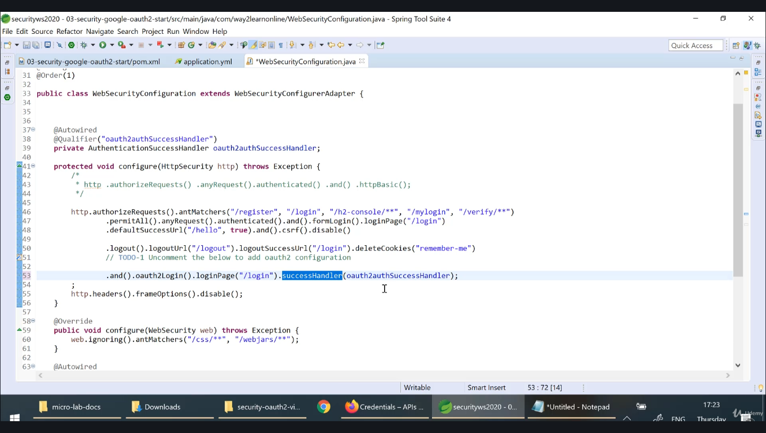

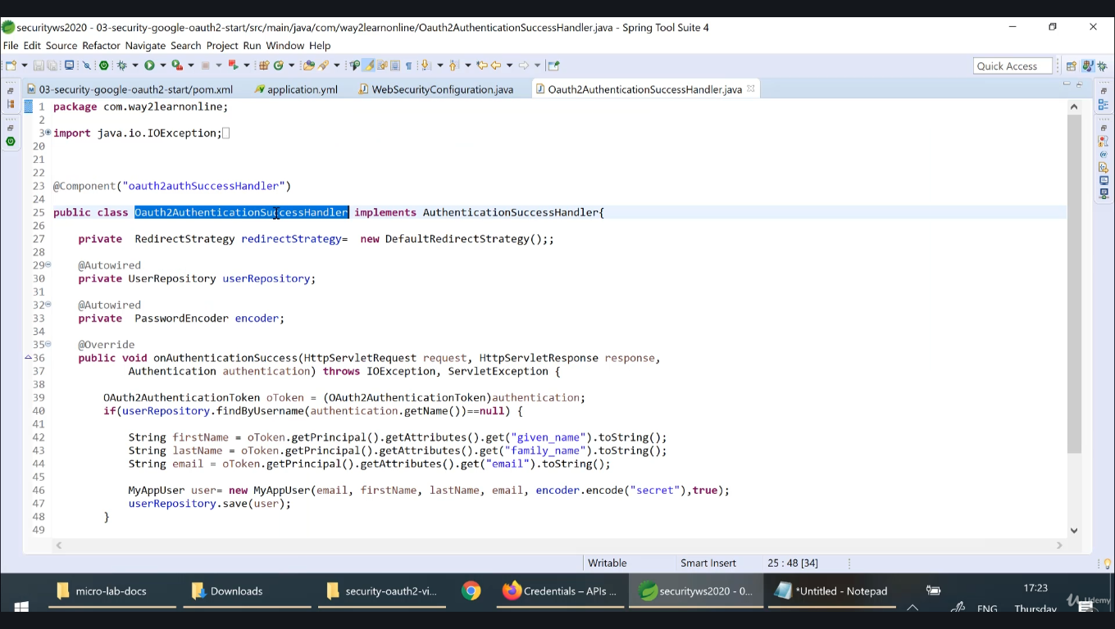

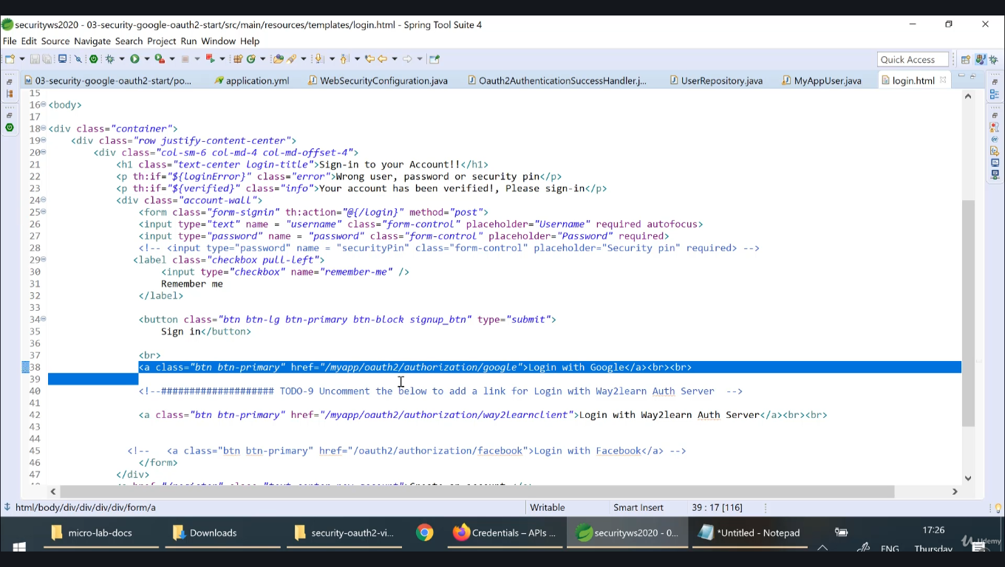

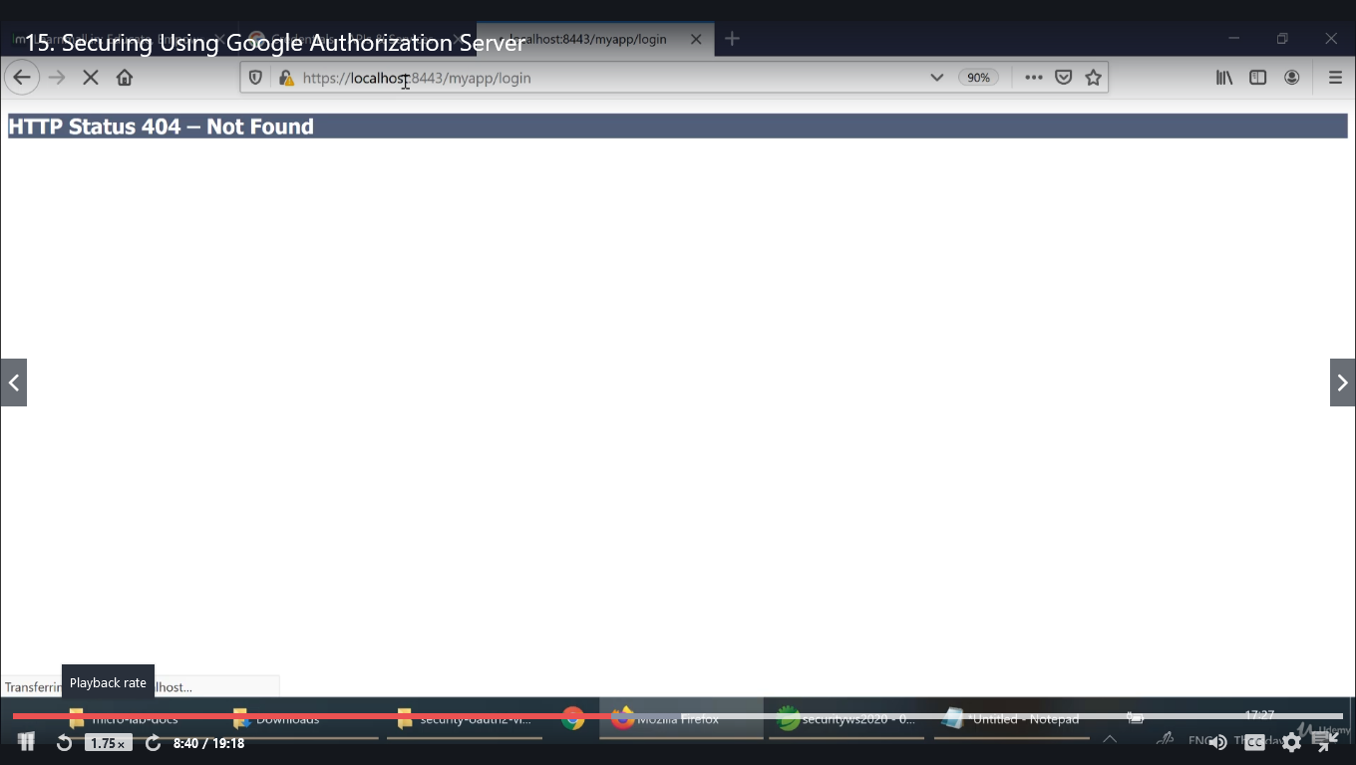

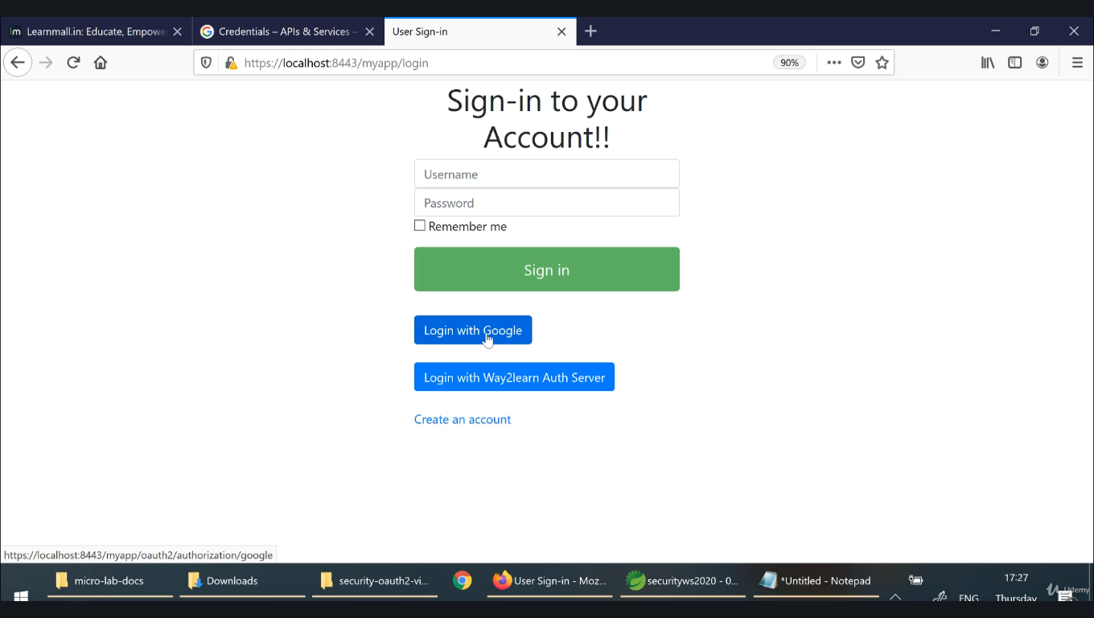

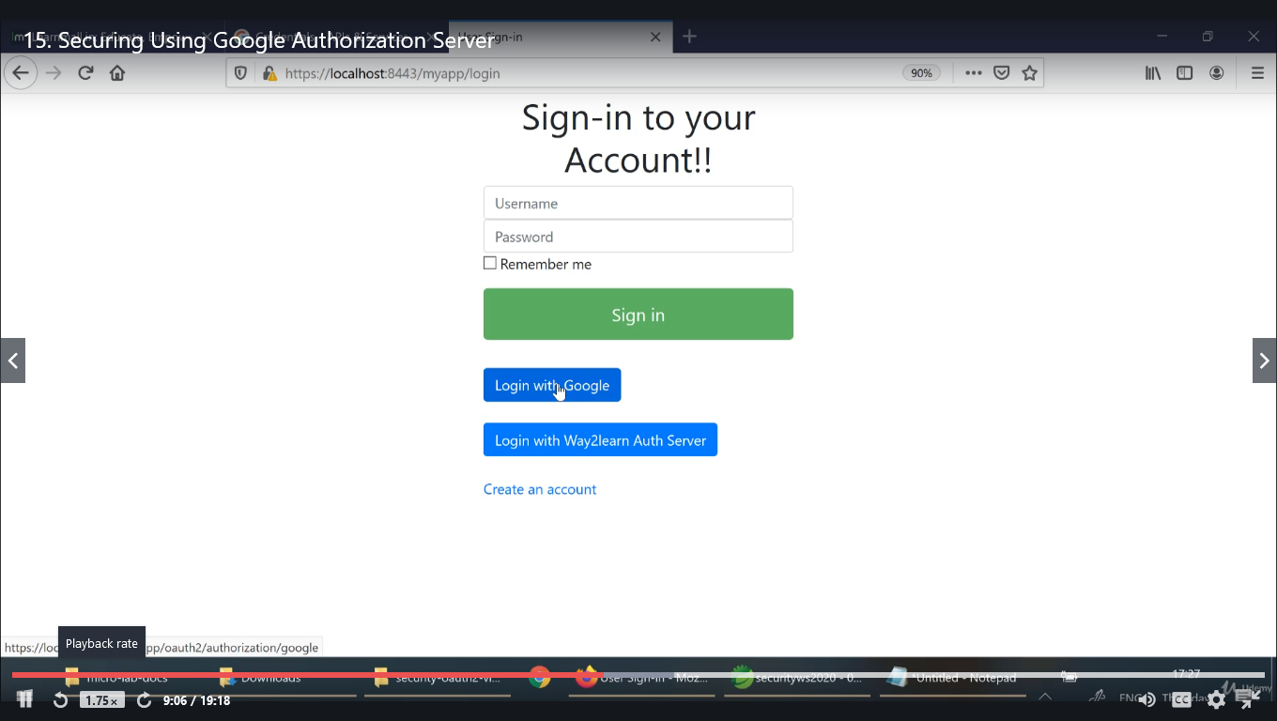

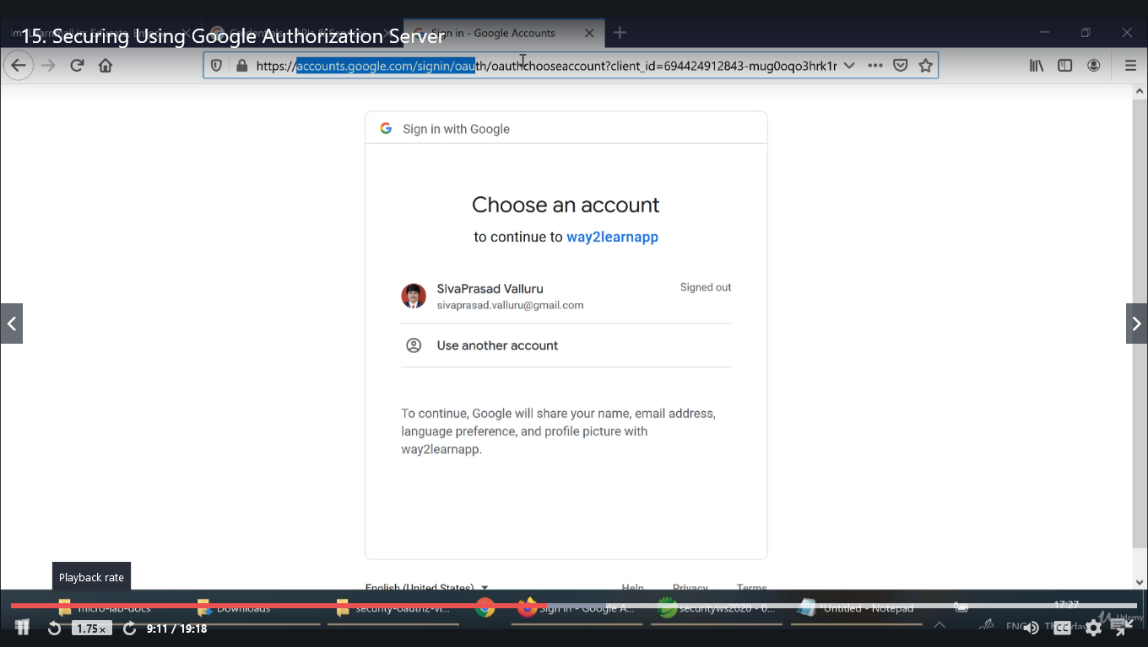

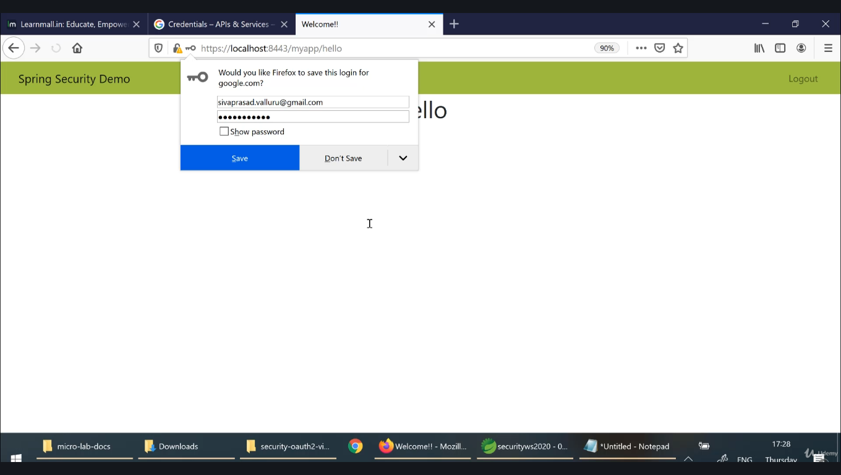

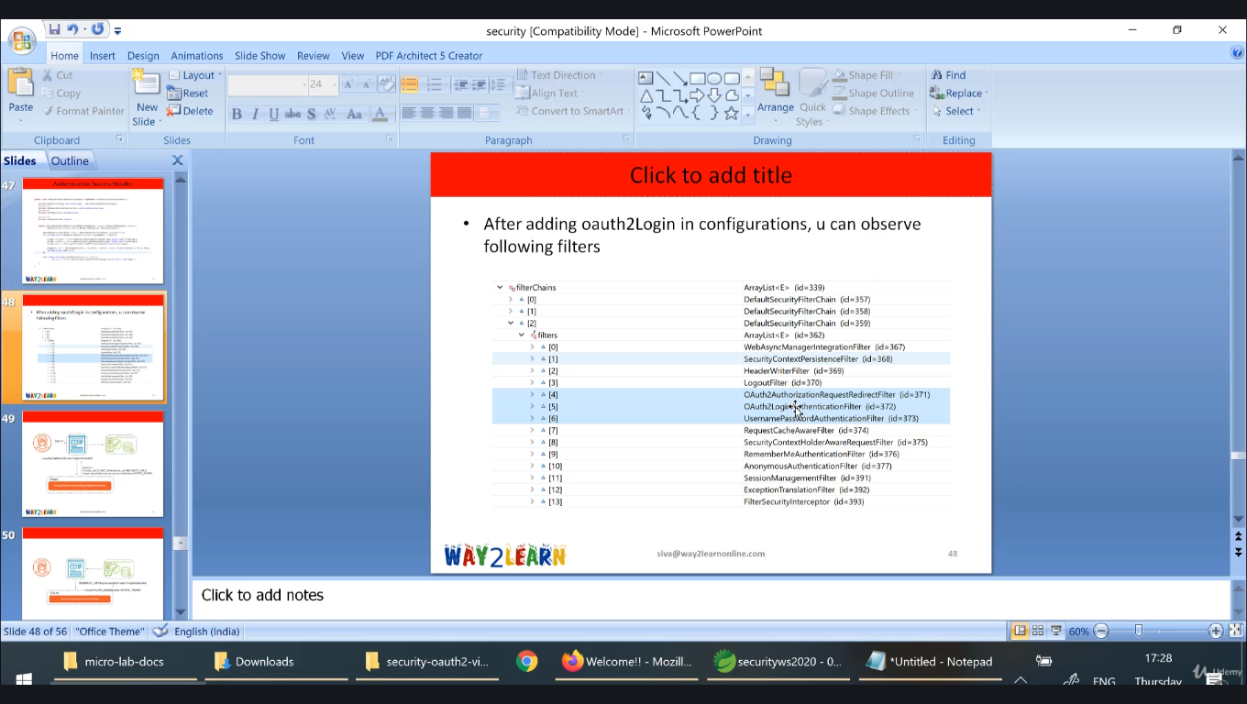

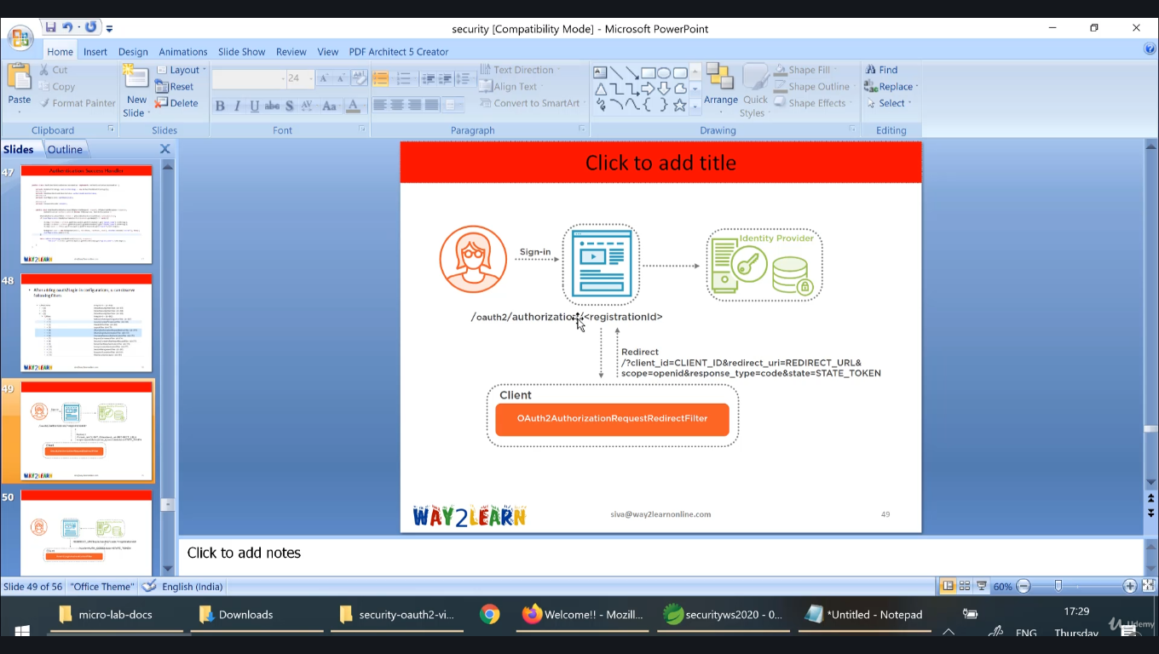

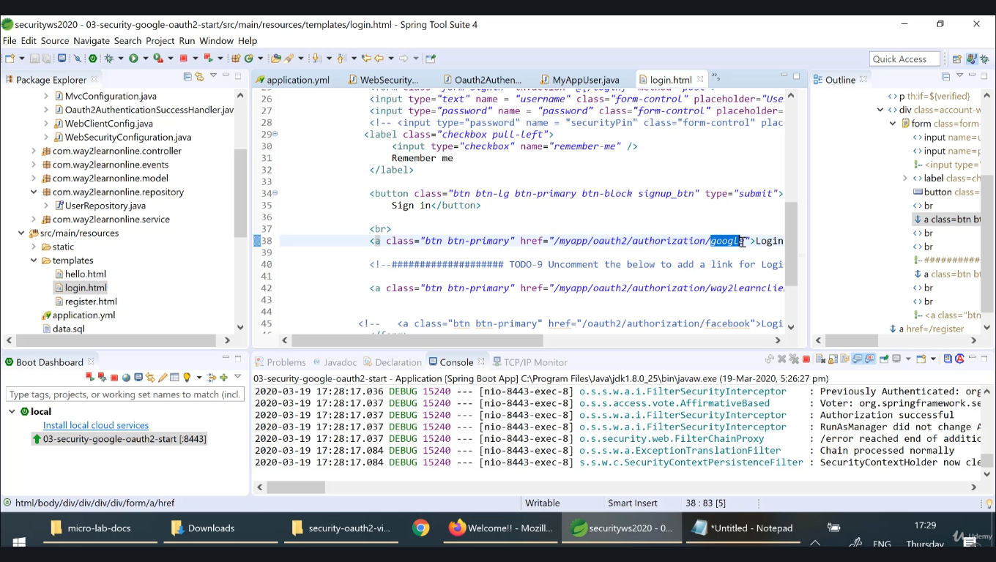

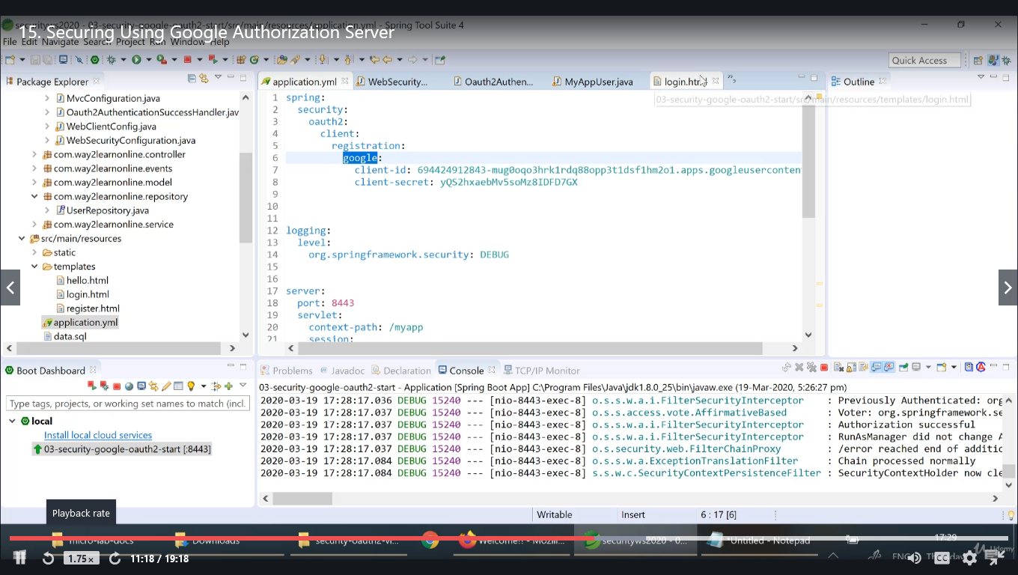

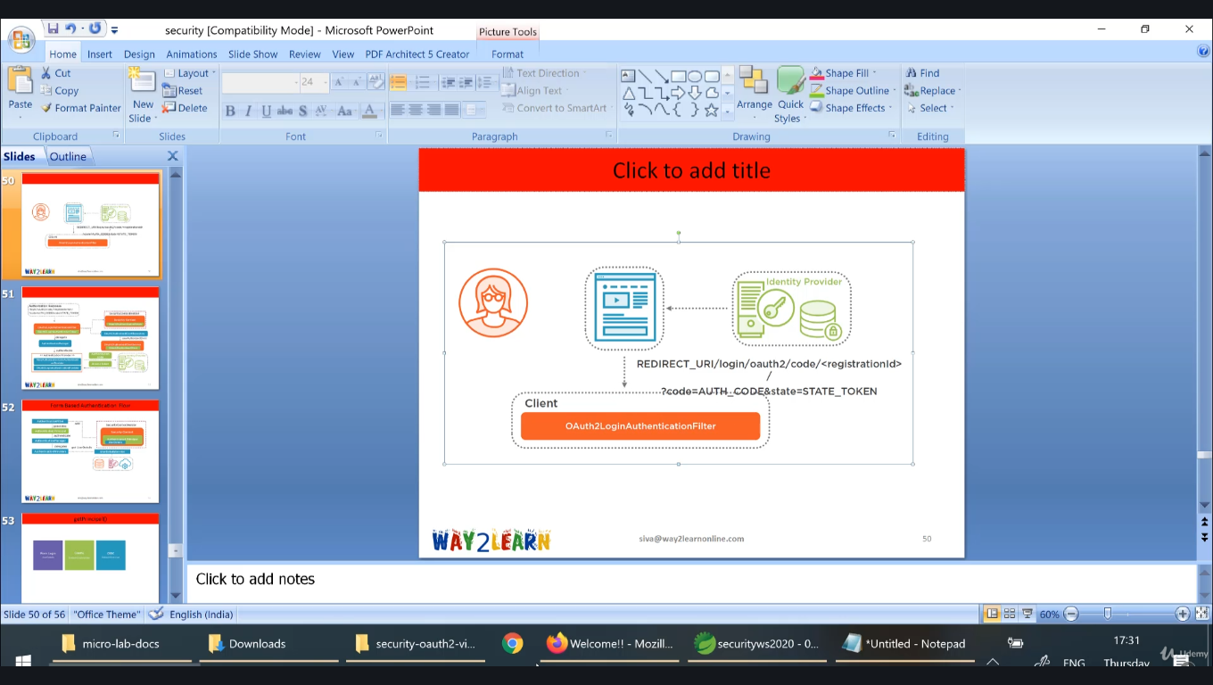

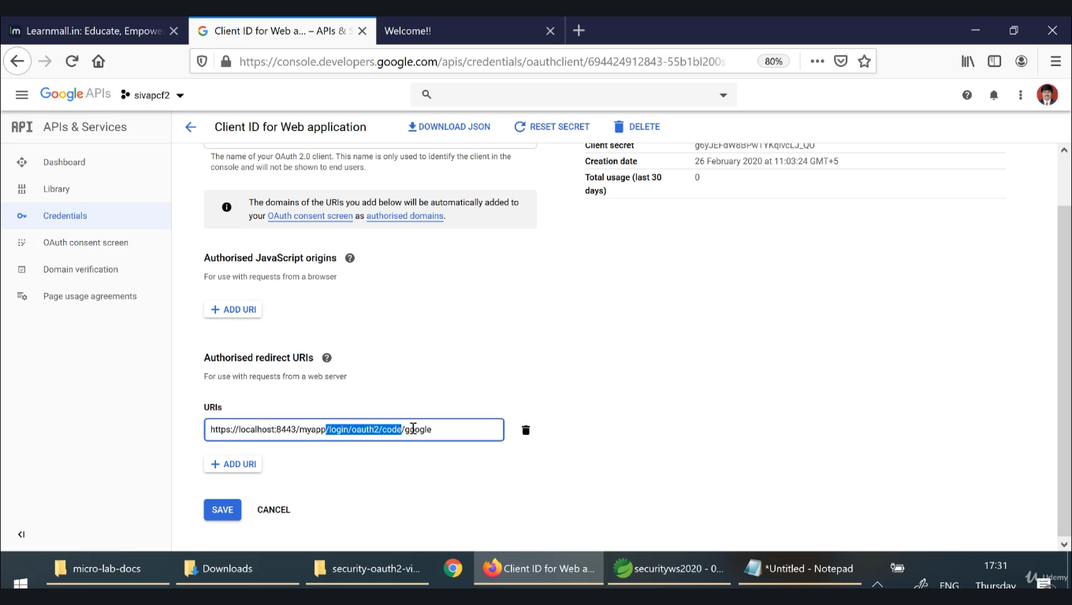

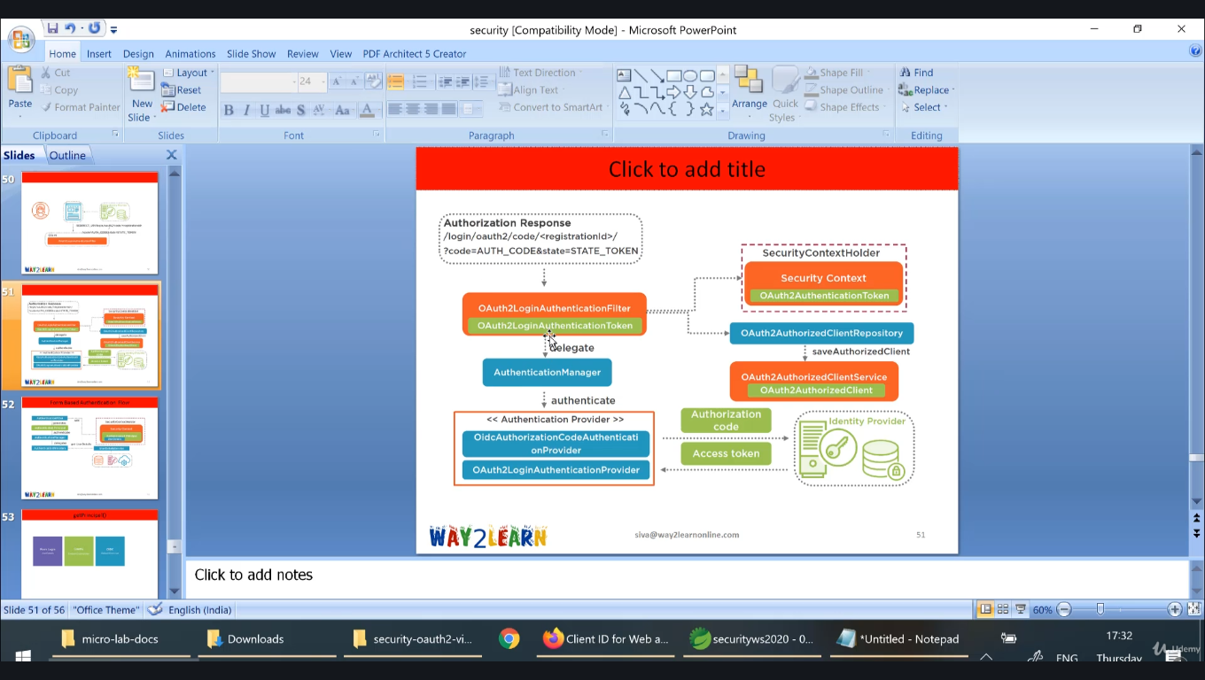

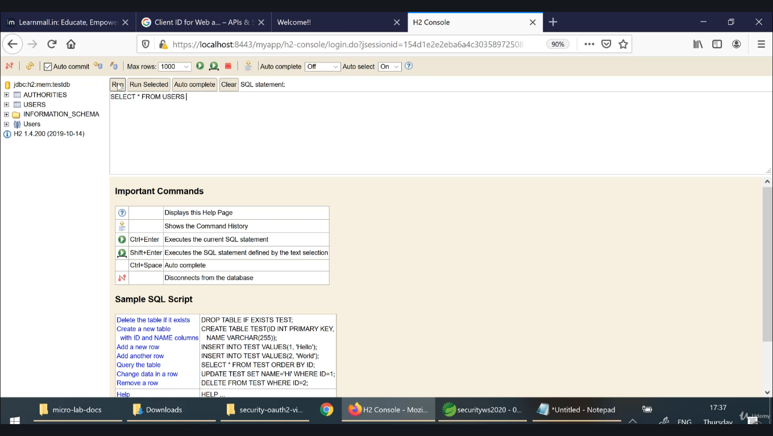

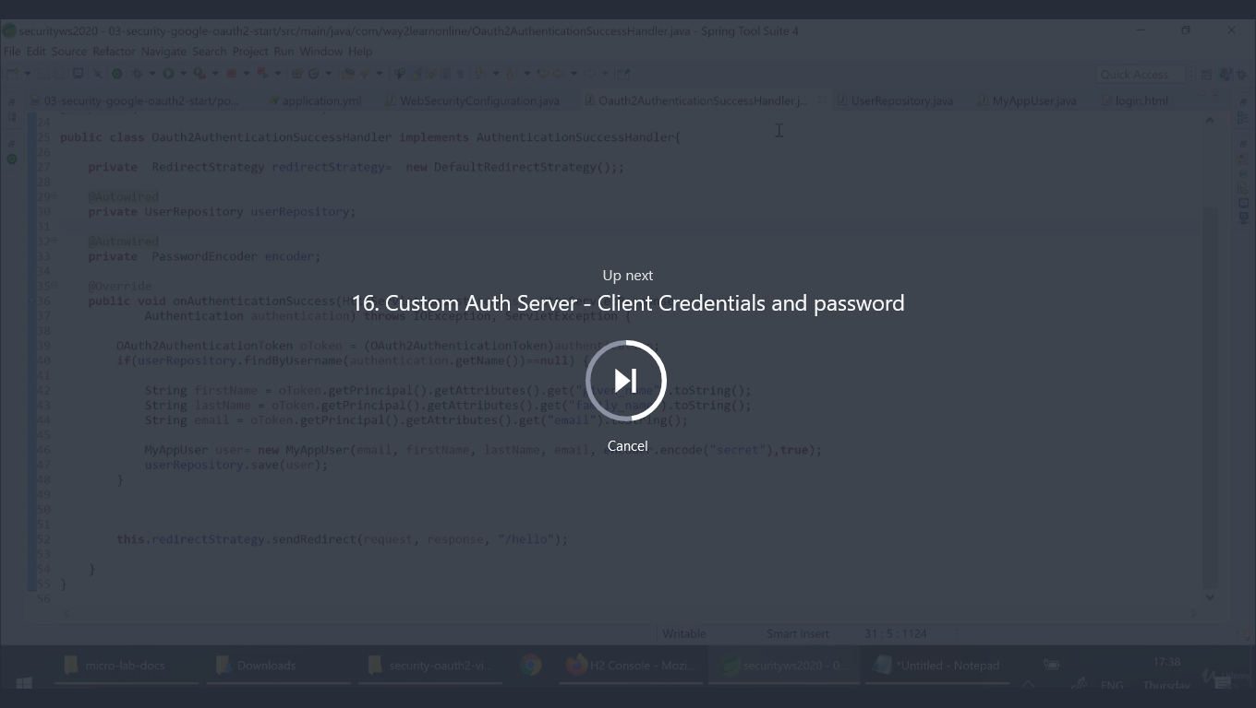

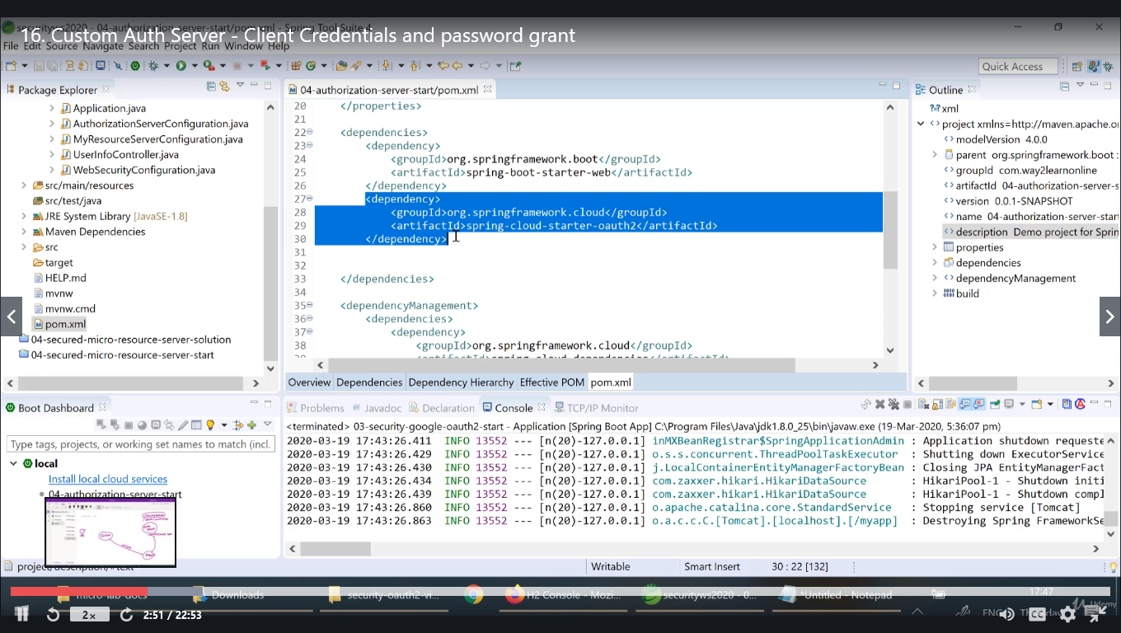

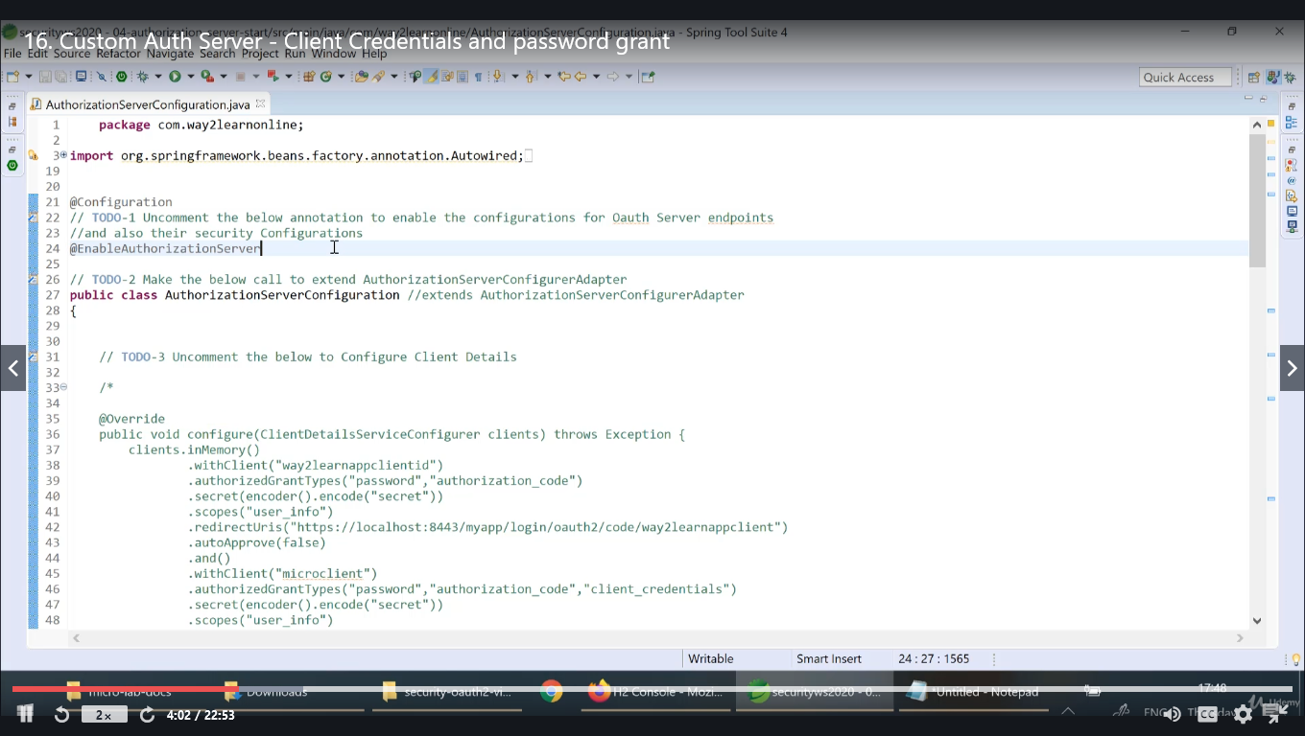

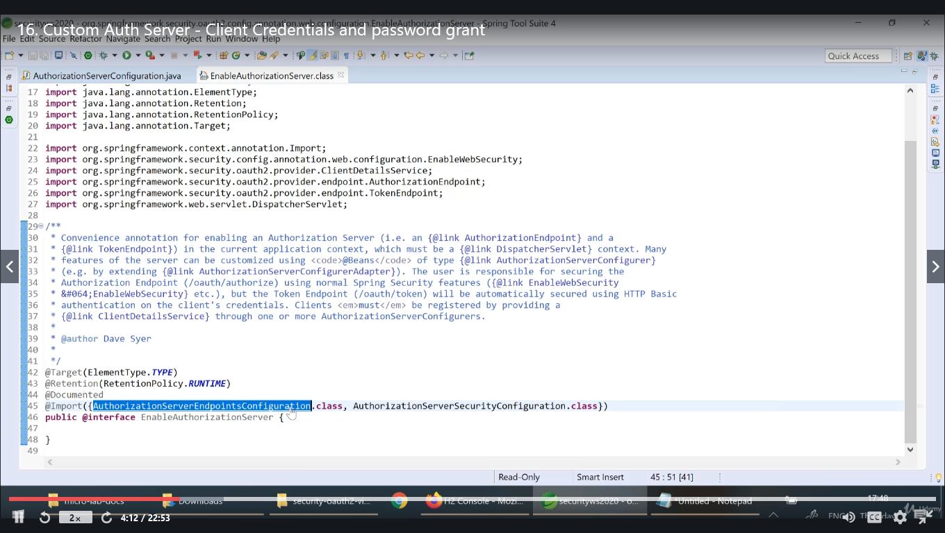

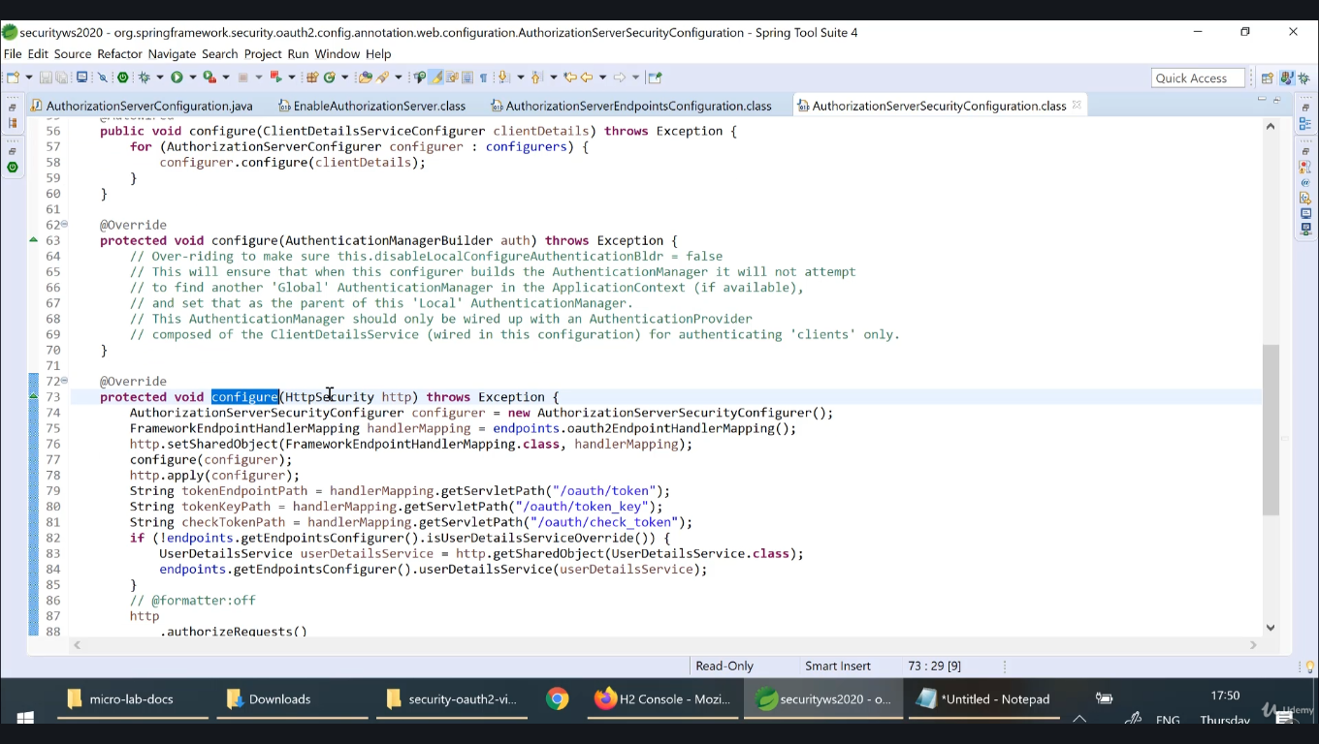

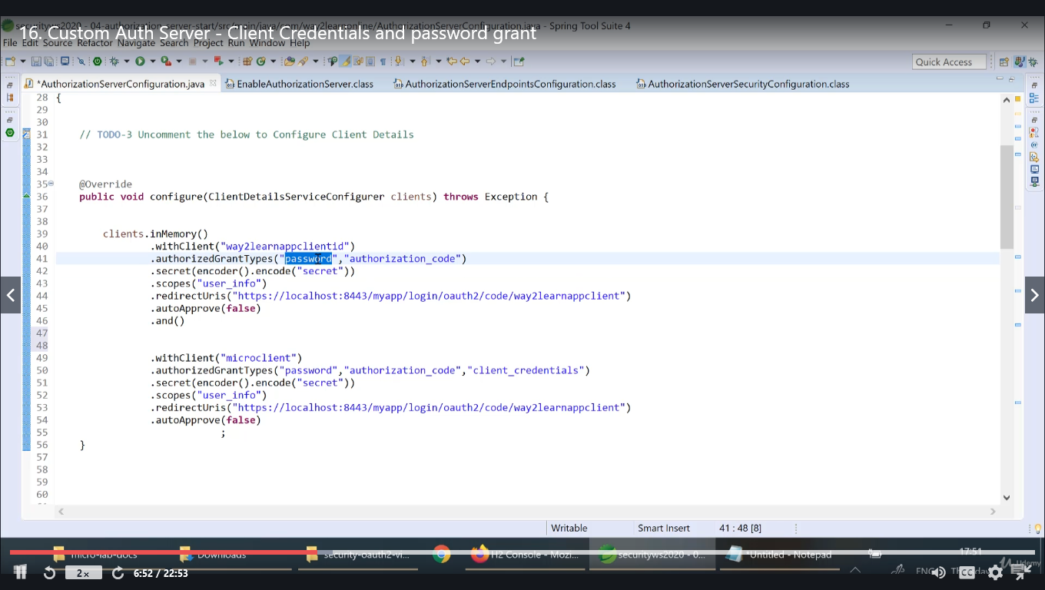

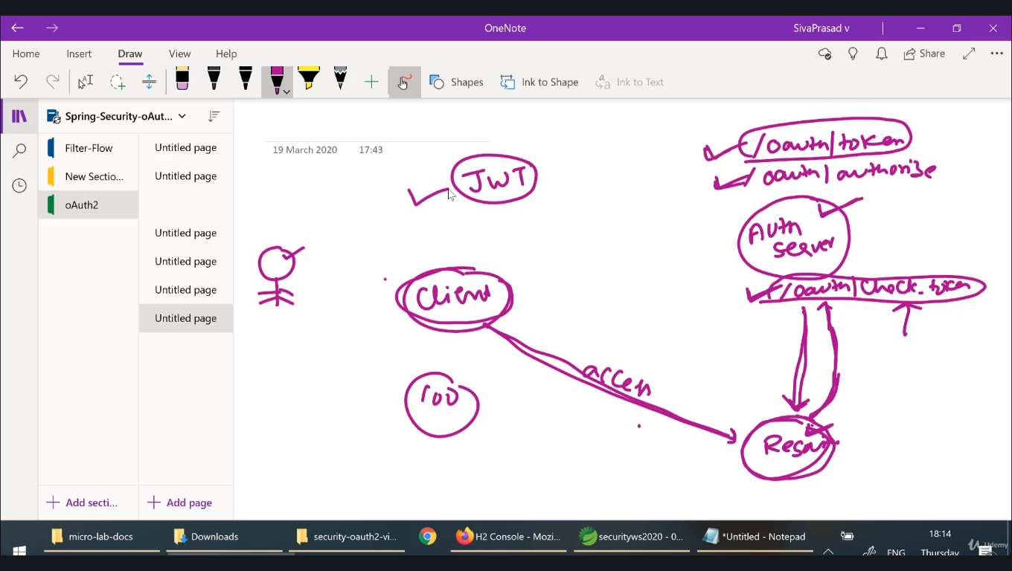

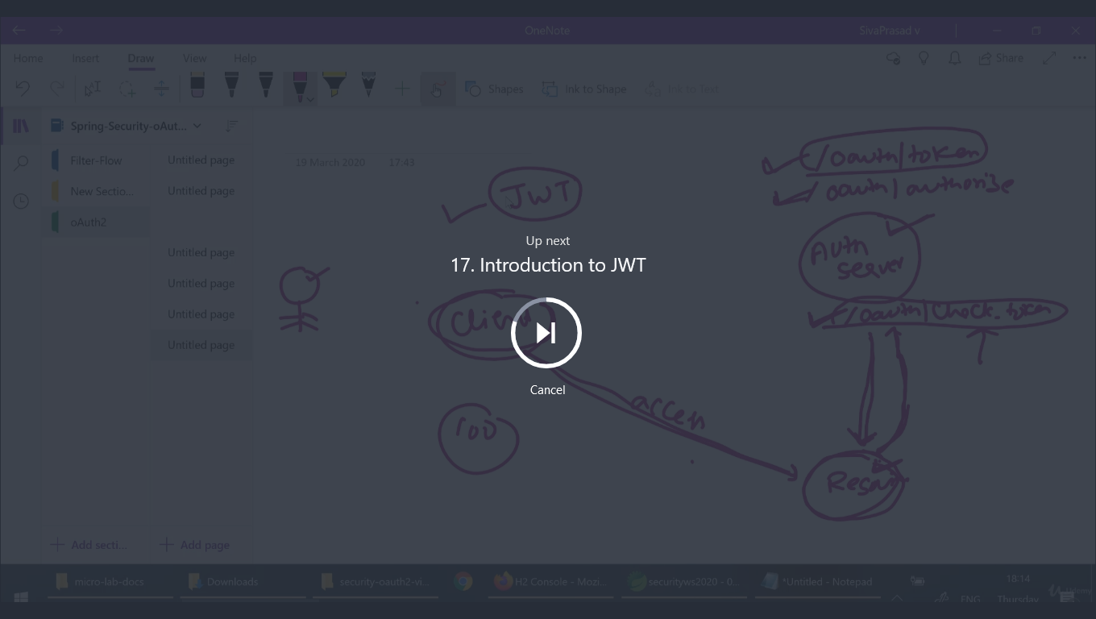

Everytime we need not to get the access_token from the server, to avoid this overhead n/w calls, servers responds with jwt token that has three parts header, payload,signature.

Client can validate the signature for every request whether the token is valid

